01452 300212 *** gloschestfund@tiscali.co.uk *** 07946 426466
Visit us at: gloucestershirechestfund.org

Newsletter 1 2007

Greetings Friends,

A Happy, and hopefully, Healthy New Year to you all.

2006, like all it’s predecessors, was a mixture of Good News and Bad News. The bad news, of course, is that we lost three of our staunch supporters including Iris Lewis, the winner of the 2005 Doreen Roberts Award. We extend our deepest sympathy to Roy Lewis, Ann Lloyd and Margaret Brown.

We are also to lose the services of a man who has actively supported the Chest Fund for fourteen years. Paul Beard has always been first to volunteer for Store Collections and the Rikenal Car Park operation. He has made himself available regardless of the weather in spite of his ‘less than perfect’ state of health. We can ill afford to lose him but he has earned his rest. Thank you for all your support Paul, enjoy yourself and please keep in touch.

2006

We set out to raise £30,000 to pay for equipment needed in Gloucestershire Royal, Cheltenham General and Cirencester Hospitals. With the support of our local authorities, service organisations and, of course, you we made our target. Unfortunately Cheltenham General hospital was unable to accept the Tosca Monitor needed by the doctors because the running cost of the equipment was about £200 per patient and could not be covered by the hospital’s budget. However we did find several items of equipment still needed by the hospital and for which we could pay the maintenance so the patients still got the benefit of the money you helped to raise.

2006 was also a year of celebration. The Gloucestershire Chest Fund was 15 years old. During that time we raised, and largely spent, £330,000 for the benefit of Gloucestershire’s patients. One of the projects was to donate £30,000 to Professor Hugh Barr to aid research into early detection of infective lung diseases. This research has proved extremely successful and on 22nd. August Professor Barr addressed an invited audience of physicians and local dignitaries to acquaint them with the results and to express his appreciation of the part played by the Gloucestershire Chest Fund.
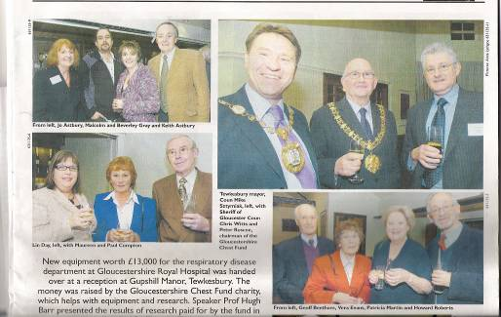
Picture printed in Citizen’s ‘Weekind’ Bib & Tucker feature dated 23rd. December shows some of the attendees at the Gupshill Manor Celebration.

The evening was comprehensively covered by the Citizen and provided some very welcome publicity for the Fund

Pulmonary Rehabilitation

Pulmonary Rehabilitation

Do you remember this one? We spent £28,000 proving the need for and benefits of a pulmonary rehabilitation service. We then ‘left the ball in the NHS court’. Well the good news is that they now appear to have picked it up. Cathy Cambell, a former Practice Nurse, has been appointed ‘Respiratory Specialist’ by the PCT and her main priority is to set up pulmonary rehabilitation services in Gloucestershire. Her efforts will coincide with those of Louise Scott-Hawkins, who ran the services that we funded, and is now setting up as an independent sponsored consultant to provide similar facilities. The result will be pulmonary rehabilitation services in Gloucestershire. This is precisely what we fought for; it will be interesting to see if the NHS acknowledges your contribution.

2007

We have already received requests that will require £30,000. Unfortunately ‘Hi-Tech’ equipment costs money. We also need to get some money in the bank to provide a transport service for those who need it to attend Pulmonary Rehabilitation services once they are up and running. How can you help?
- Make a donation
- Raise some money:
  - Coffee morning, sponsored event (anything from crib to marathon will do), remember the Fund if you have to arrange a funeral. Donations ‘in lieu’ of floral tributes often produce amazing results, remember the Chest Fund in your will (We’re in no hurry to collect this one!), place a collecting box in your local store or pub. Whatever you do – Thank You!

We’ve already made a start. Steph and Charlie McKeever, ably assisted by their two wonderful children, conducted a store collection at Tesco – Stow-on-the-Wold and produced £466.00. That is a pretty good ‘family contribution’ – on behalf of the Trustees – ‘Thank you all’

Here’s a date for your diary: 2nd. June 2007 – we will staff the car park at the Rikenel Health Centre, Montpellier, Gloucester. To do this job right I need the services of 12 helpers working for 2 hours each. It’s easy work because we are providing town centre parking at a nominal price. You can even sit down as you take the money. Please reserve the date – I’ll contact you nearer the time to see what you can do.

Is There Anyone Out There?

Paul Beard has retired after 14 years service. This means that I have two excellent, friendly sites who have supported us by displaying collecting boxes who need servicing once every six weeks. All you need to do is collect the full box and replace it with an empty one then get the full box to me. You can deliver it to the office or, if you prefer, I will make arrangements to collect it from you.

The sites are:
- The Spa Shop, Cashes Green, Stroud.
- The Rising Sun, Hartpury.

Please contact me if you are willing to collect this money for me.

Phone me at the office, at home on 01452 536202, on my mobile or by e-mail.

Thank You all for your support

Ron Hannam

