The Gloucestershire Chest Fund Ltd.
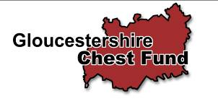

Suite’E’, The City Business Centre, Llanthony Road, Gloucester GL2 5JH, 01452 300212

Web site : www.gloucestershirechestfund.org email: Ron@gloucestershirechestfund.org

Newsletter 2/2011

Dear Friends
£501,300
When our charity was launched some 20 years ago, the Trustees ambition was to raise £500,000 over a period of 10 years. This target, for a small, locally based medical charity, has proven to be very optimistic. However, at last, I’m delighted to report that through the hard work and dedication of our supporters and volunteers our original objective has now been achieved. The Trustees now wish to place on record their sincere appreciation to everyone who helped to make this ambitious endeavour a reality. WELL DONE EVERYONE!

20th. Anniversary Celebration

Dr. John Prior, Trustee and Co-founder of the Chest Fund, and Miss Karen Wiggins, his fiancée, entertained over 50 guests to a pig roast at their delightful home in Stone, South Gloucestershire. Everyone enjoyed the occasion and in particular the lovely desserts and puddings prepared by Karen. Dennis Johns, our regular performer at our annual social event, provided the entertainment and the afternoon was rounded off with a raffle that raised over £200.
The Trustees thanked John and Karen for their outstanding hospitality and wished them, every happiness, in their forthcoming marriage.
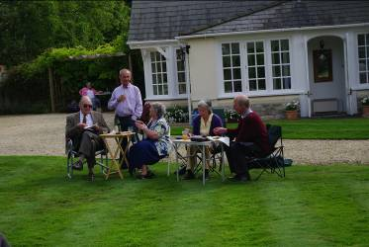
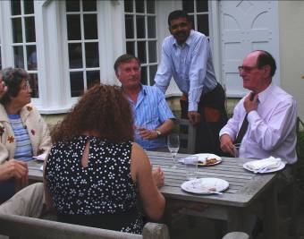
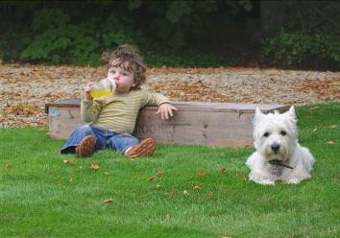
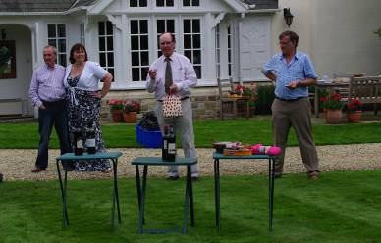

Where’s Punch & Judy? Dr. Prior Greets his guests Bernard cooper, Raghu and

Terry Adams draws the raffle which made £200
Our youngest Supporter Dr. Prior greets his guests. Bernard Cooper, Raghu
and Terry adams entertain
some of our supporters
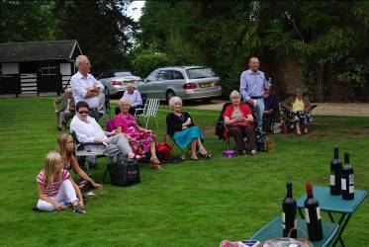
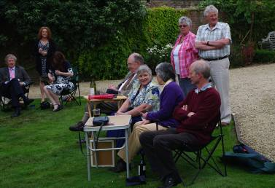
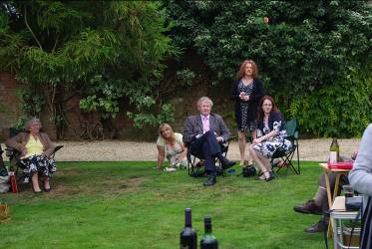
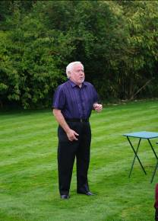

Pat Dowling, Ron Hannam Former Chairman, Dr Peter Our auditors share the day
and some supporters Roscoe greets old friends with ladies from Cheltenham Dennis Johns ends
Sparks Rotary Club the party with a song

What’s been happening?

During the year we have manned car parks at Shire Hall and Rikenel as well as numerous collections at supermarkets throughout the county. These collections provide us with a very useful source of income and also help to increase the public awareness of our charity. I appreciate that not everyone can help with store collections but are you able to hold a coffee morning, organise a sponsored event or simply make a donation?
Store collection at ASDA, Gloucester, helped by Peppa Pig
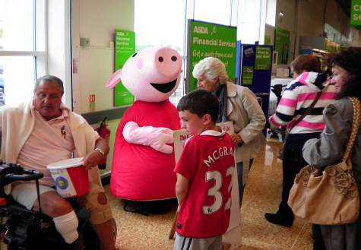
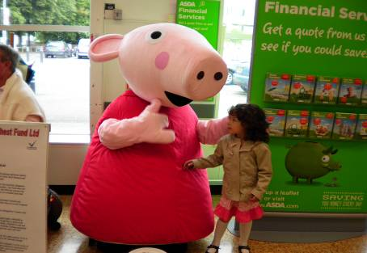
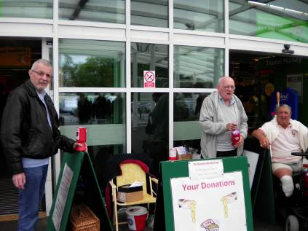

Dennis Hayward goes for ‘broke’ Peppa Pig talks to a young shopper Pat Mahoney and John Rush
With a collecting bucket collect outside ASDA

It is also becoming increasingly popular to celebrate the life of a loved one by inviting donations to a charity, at their passing, in lieu of floral tributes.

Another Challenge!

Our Chairman, Bernard Cooper, helped by his son David, successfully completed the Cheltenham Circular Challenge, in aid of the Chest Fund. It’s very hard work – I know as I competed in the same event last year. The final sponsorship figure was a little over £700. Well done David and Bernard.

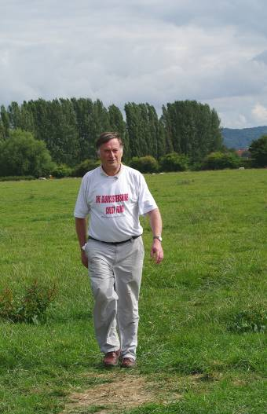
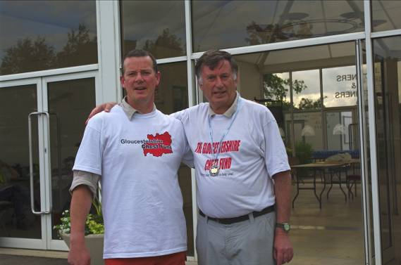
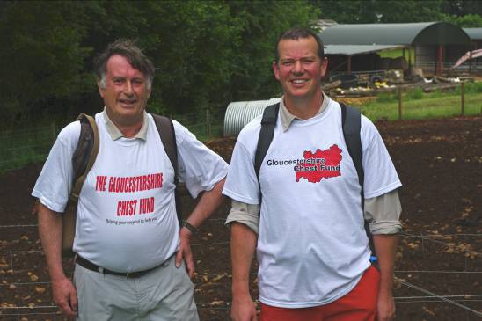

Bernard and David before the start Done it! 26 miles 384 yards in
(The easy bit!) support of the Chest Fund.
Well done David and Bernard

There’s a long, long trail
a winding!

Sponsored Skittles Match

On Tuesday 16th August 2011, the Chest Fund once again tackled the might of the Rising Sun team at Hartpury. Unfortunately the Rising Suns is still leading the 6 year series but nevertheless everyone thoroughly enjoys the challenge and the excellent buffet, laid on by mine host, Tom Madden. Total sponsorship monies should once again exceed £600. Well done everyone.
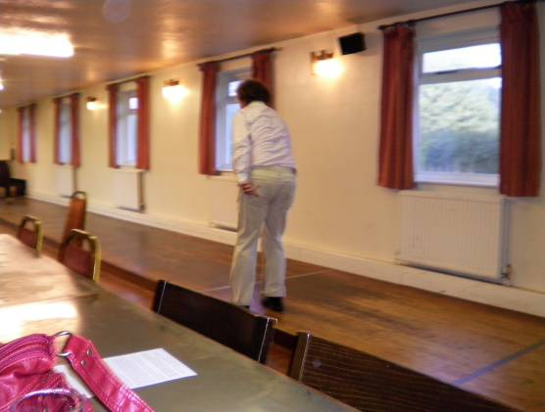
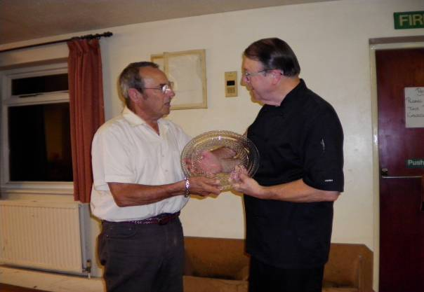

Roger Harrison bowls for the Chest Fund Ron Hannam presents the trophy to Tom Madden

All That Jazz

The ‘Cake Walking Babies’ a ‘trad. Jazz group from Frampton-on-Severn, performed at the MidGlos I.B.C. for the benefit of the Chest Fund. The band performed two concerts, one in April and one in October. These trips down one of music’s ‘memory lanes’ entertained appreciative audiences and produced over £350 for the Chest Fund.
Our sincere thanks to Beverley Laughe and her wonderful musicians for their help and support.

Christmas Draw and Social Evening

It’s that time again! All the prizes for our annual draw are donated by well wishers and once again they are excellent. I’m enclosing a supply of tickets – please, please try and sell them all. More are available on request.

The draw will be held, during the evening of 2nd December 2011, at St Georges Church Hall, Court Road, Brockworth, following our cheese and wine event. Tickets are only £8.00 each, which will include cheese, mince pies and a glass of mulled wine or a drink of your choice. Our usual entertainment has also been arranged. Please come along with some friends, I’m sure you will enjoy this start to the festive season.

Please phone 01452 300212 for more draw tickets or tickets for the cheese and wine event.

Thank you for your continued support, it is greatly appreciated by everyone but in particular by the many chest disease sufferers in the county.

Ron Hannam

