Suite’E’, City Business Centre, Llanthony Road, Gloucester GL2 5JH.
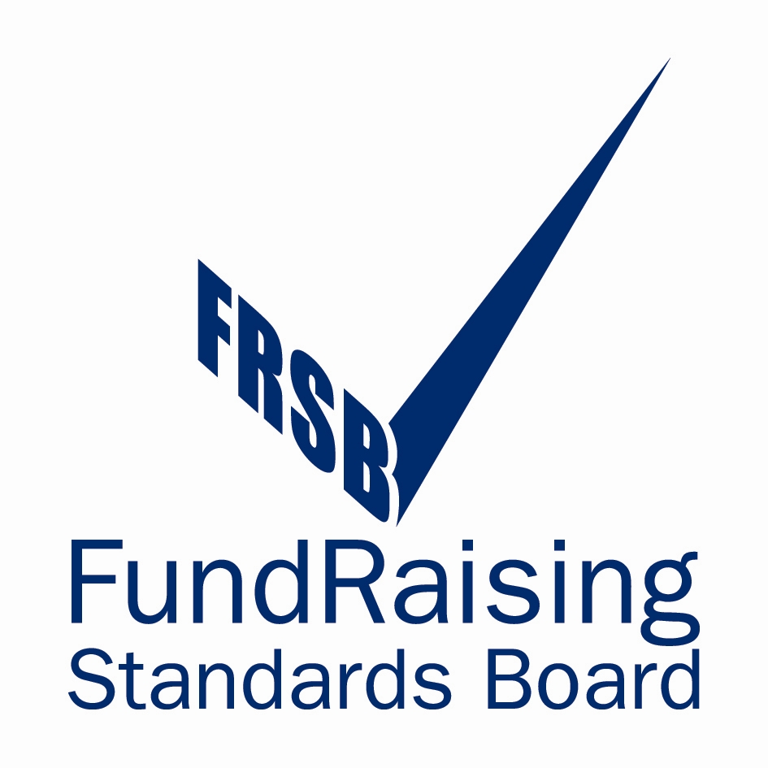
Tel:01452 300212, email gloschestfund@tiscali.co.uk
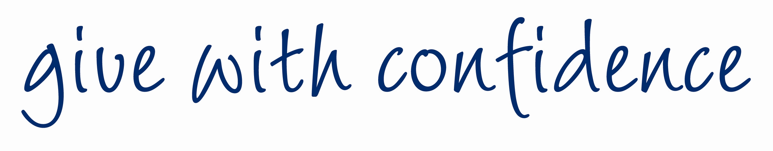

Newsletter 2-09
Dear Friends,

In the words of dear old Bruce Forsyth “Didn’t you do well!.

Less than two years ago we undertook to raise £80,000 to provide E.B.U.S. a system of guided needle biopsy that would provide early, accurate non-invasive diagnosis for those patients feared to be suffering from lung cancer. There were those who felt we might have ‘bitten off far more than we could chew’. I am delighted to say they were wrong; we have raised over £80,000.

The local NHS suggested that instead of two sets of equipment in different hospitals we would be better served with one enhanced processor and two bronchoscopes in a central location. This would mean that while one bronchoscope was being sterilised the procedure would continue to be available. The cost of the equipment and accompanying software would have been £160,000. The Trustees offered to pay half (£80,000) and asked that the NHS fund the remainder.

However, the NHS is once again short of money; the local press has reported that the service must effect economies in the current financial year to the tune of £25m.. Consequently any hope of the service funding £80,000 for a new procedure is non-existent.

The Trustees, ever mindful of patients’ needs, have decided to find out what equipment can be obtained. for £100,000 or less. We could then provide the service without any funding from the NHS apart from day to day running costs.

We will do all in our power to ensure this necessary service is available as soon as possible. We will continue to raise funds in pursuit of a slightly higher target of £100,000.

On behalf of the Trustees and all at Gloucestershire Chest Fund we thank you for your help and support. We are nothing without you.

Fundraising update

What a Winner!

Paddy Power, the well known Irish Turf Accountants extended a ‘Free Bet’ to selected recipients to guess the colour of the hat worn by Her Majesty The Queen on Ladies Day at Royal Ascot. The hat was white but with a band of blue and green. Paddy Power decided to pay out on all three colours. Our President, Dr Willie Carson O.B.E. guessed blue and won £1,500 which he instructed Paddy Power to donate to the Gloucestershire Chest Fund. How’s that for support from the top?
Our sincere thanks Mr..President.

Dennis Hayward, one of our supporters has placed 18 collecting boxes around Gloucester. He also organised and ran a Race Night at the Victory Hotel, High Street, Gloucester that raised £304.00 Well done Dennis!

Rikenel car park was staffed by Fiona Miles, Dennis Hayward, Hilary Howe, Mary and Colin Cavanagh, Les Davis and Bob Fletcher on 9th May, we raised £204.00 thanks a lot everyone.

What’s going on???.

We have 5 supporters who walked in the Cheltenham Circular Challenge on Sunday 14th. June.
Sponsorship money is still coming in, thanks again to everyone.
The annual sponsored skittles match will be held at the Rising Sun, Hartpury on Tuesday 11th. August. This is a real’ fun night’ Please come along and see for yourself.

September 5th. we will again staff the car park at the Rikenel Health Centre, Gloucester and I will again need your help. Just two hours of your time to cover any period between 8 am and 4 pm. Please help if you can.

Sunday 6th September is the 10k Cirencester Charity Run. We have a team running for the Chest Fund and we will have an Awareness Table at the start. We’d love to see you..

Friday 4th. December is the date of the Christmas Social. This event seems to get better every year. We will have food, drink, entertainment and the draw. All we need to make it an even bigger success is you.

THIS IS NEW

Enclosed with this newsletter you will find a ‘Loose Change Collecting Box’. May I ask you to put it somewhere prominent in your home? Perhaps by the phone and every time you make a call put a couple of coppers in, or just empty your loose change into it a couple of times a week. You could, if you wished, even use it as a swear box and put 10p in every time you use a naughty word!

However you use it please give it a try – it will mean a lot to the Fund.

When it’s full you can either send me a cheque or simply give me a ring and ask me to come round and collect it. Whatever suits you!!
Please turn this into this

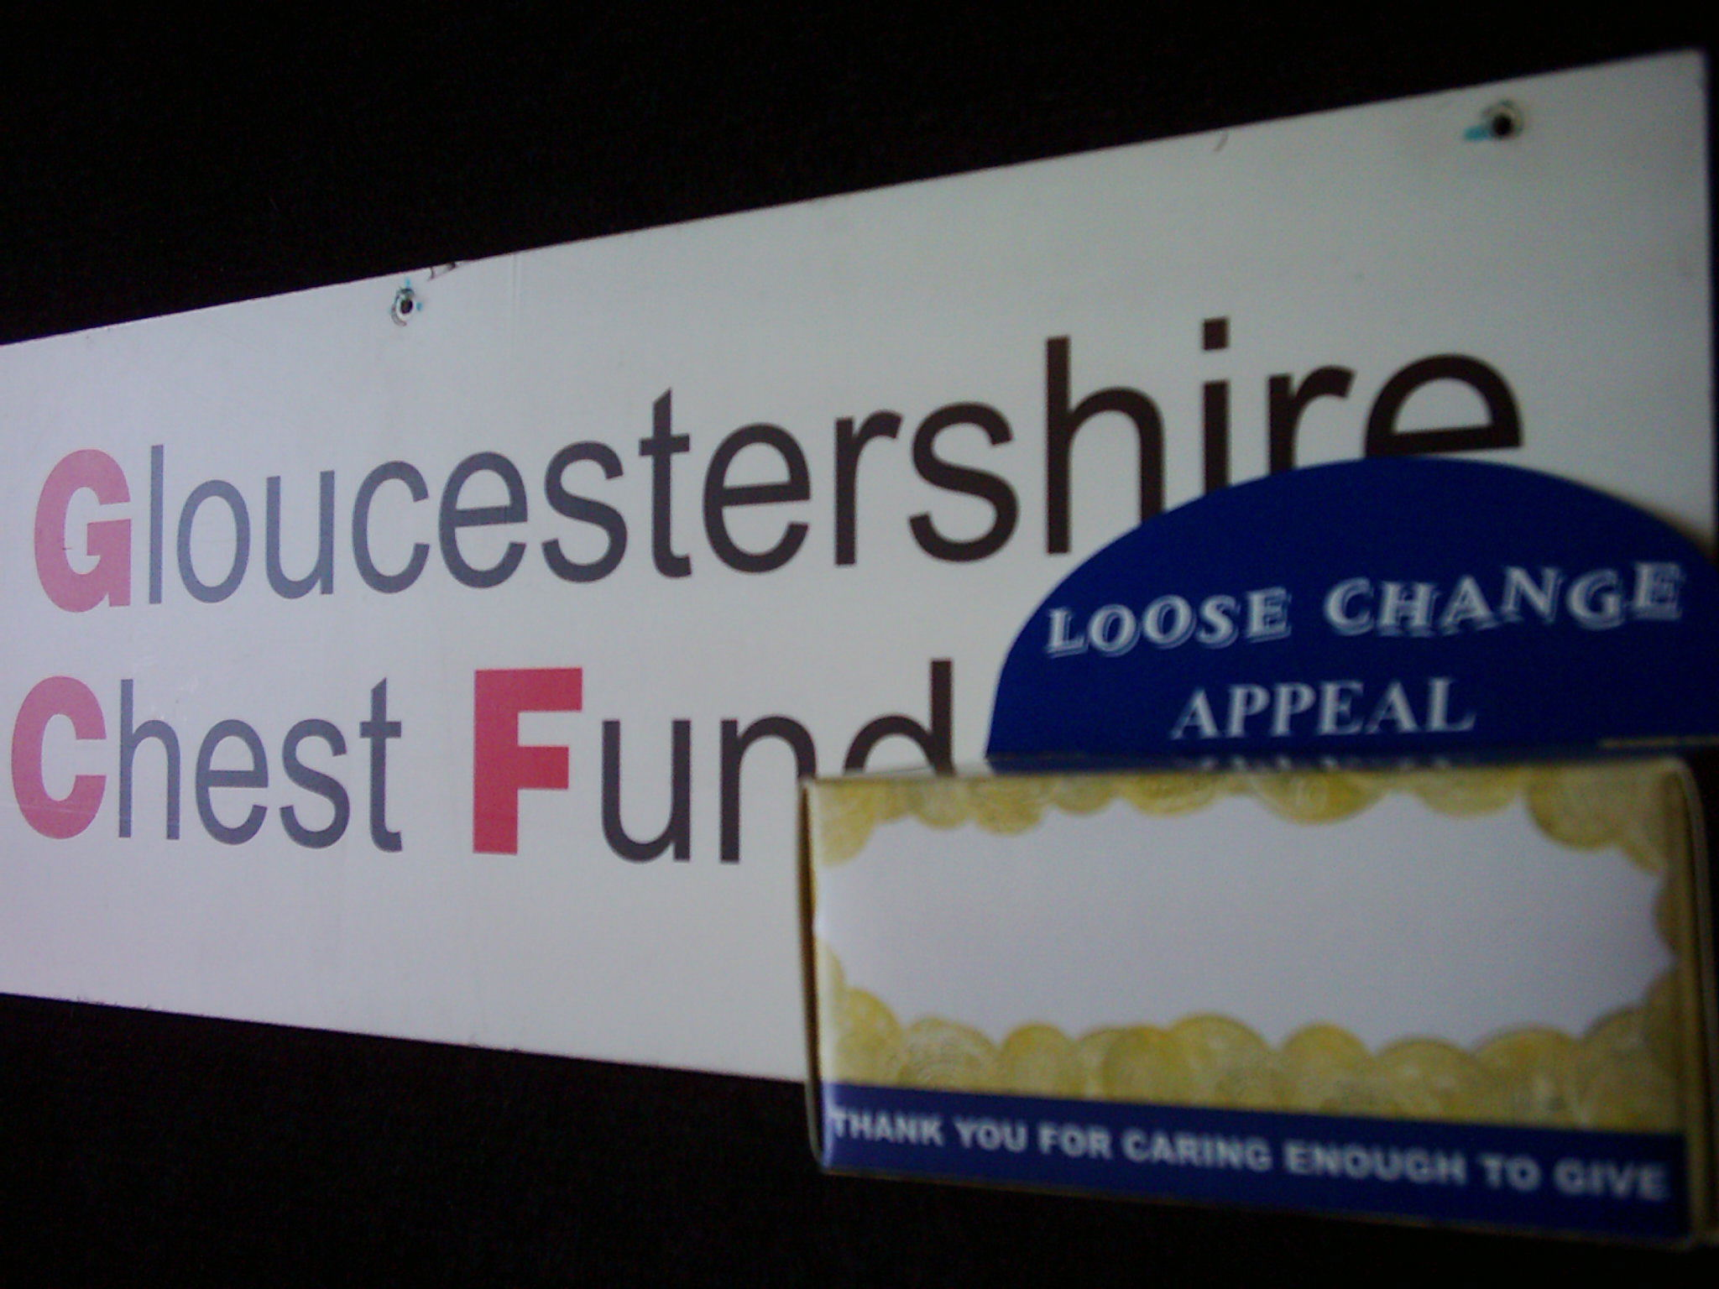

Please stay healthy – enjoy the rest of the summer
Thank you for your support

Ron Hannam

