

Newsletter, Spring 2012

Dear Friends,
A very sad day

Dr John Prior, Co-Founder of our charity, a dedicated , brilliant physician and one of the nicest gentlemen it’s been my privilege to meet died suddenly and unexpectedly on 20th. November 2011.
Gloucester Cathedral was packed with family, friends, colleagues and many patients both past and present, all of whom had come to pay their respects to this extraordinary gentleman.

We all extend our sympathy to John’s wife, Karen, his sister and the rest of his family.
He cannot be replaced. I am sure he will never be forgotten.

The Trustees of the Gloucestershire Chest Fund have decided to create a Dr John Prior Memorial Fund designed to give help to lung function department nurses and staff who find it difficult to raise the necessary money for their training fees and modules. This will help to ensure the continuation of expertise in our chest departments

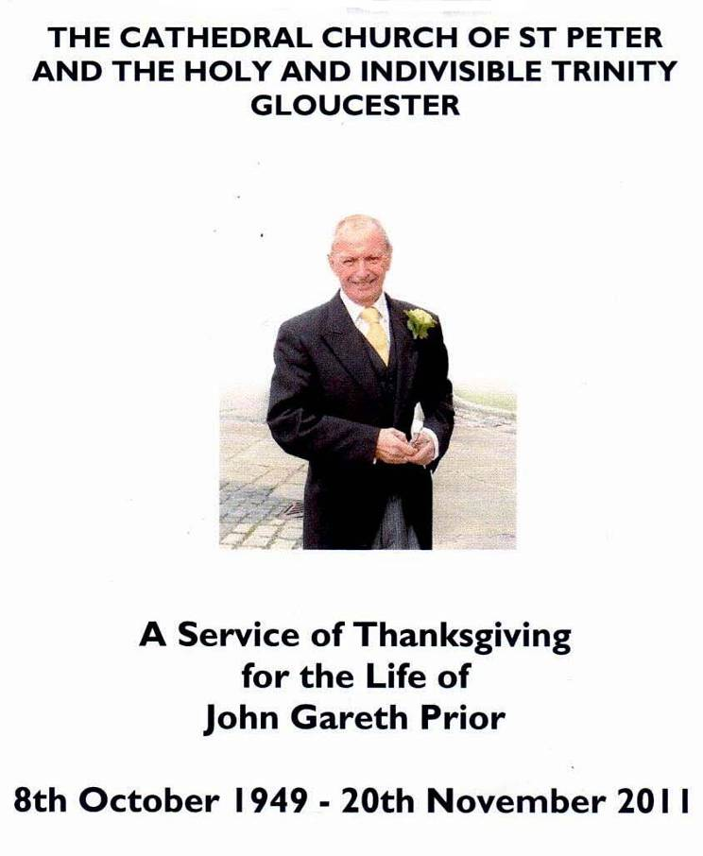

Well done everyone

We have now successfully raised the £19,250 needed to provide portable ultrasound scanning equipment for the Chest Ward, Gloucestershire Royal Hospital. The scanner is on order and will be formally presented shortly. Thus since 2008 we have raised funds to provide:
- E.B.U.S – early detection of lung cancer, cost £107,000
- Portable ultrasound scanner for Cheltenham General Hospital, cost £19,250
- Portable ultrasound scanner for Gloucestershire Royal Hospital,cost £19,250

Our sincere thanks go to all of you who have run coffee mornings, raffles, sponsored events or simply sent donations.
Our success is entirely due to your support. Well done and thank you everyone.

Where to next?

The Trustees are considering trying to raise the funds to provide a Pleura Videoscope to be used to benefit chest patients in Gloucestershire. This advanced equipment will assist the removal of unwanted fluid in the chest cavity and will greatly assist the early diagnosis of many chest diseases. The Pleura Videoscope is currently in use in two U.K chest facilities. The estimated cost will be in the region of £32,000

Dr John Prior Memorial Fund

The Trustees of the Gloucestershire Chest Fund consider it will be a suitable memorial to Dr Prior if we establish a Trust to pay training fees and modules for any nurses and lung function dept. staff
who have difficulty in raising the necessary funds. The Fund will be started with £5,000 and, hopefully, replenished every year.

The Trustees believe that we can best serve the memory of a physician, loved and respected as Dr Prior undoubtedly was, by ensuring that talented medical staff are receive the necessary training to up-date their skills.

If you would care to make a donation specifically for this purpose please feel free to do so.

How was Christmas?

The Annual Christmas Social was an outstanding success. This was definitely helped by the large number of our Trustees who attended. The final number of guests gave Terry Adams a few worrying moments when he began to doubt if he had ordered enough food! However, all was well. The food was excellent, the entertainment outstanding and our funds benefitted accordingly.
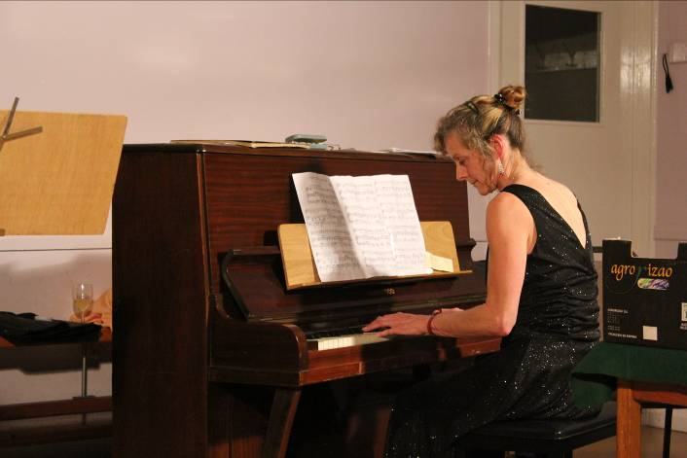
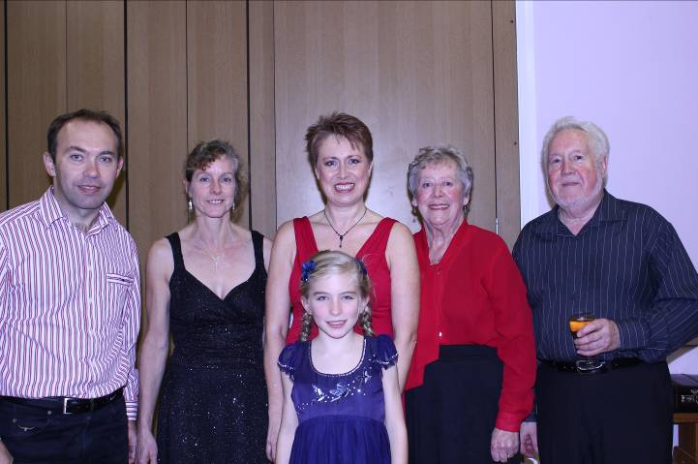

Le tout ensemble
David Lynall, Julie, Lynda Purchase, Joan Phillips,Dennis John Darcy Lyndall
Dennis Johns and his family have entertained us royally for several years
Dennis John’s musical talents have certainly spread through the family. Daughter Linda sings beautifully, nephew David plays guitar, David’s daughter Darcy also sings. The family were supplemented by Joan Phillips (Dennis’s accompanist) and Linda’s friend Julia, also a pianist.
Julia plays jazz piano

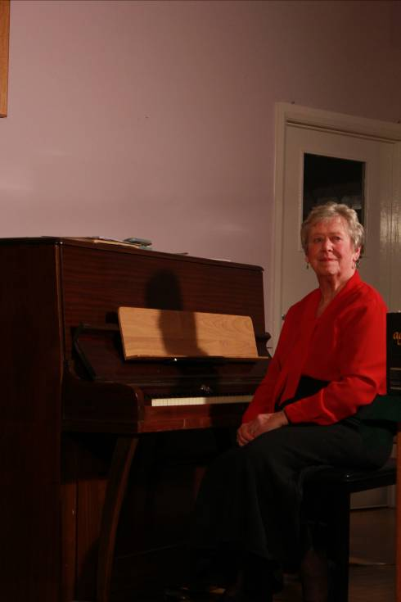

Joan Phillips

Joan Phillips, accomplished pianist and long-time accompanist for Dennis Johns. Dennis and Joan began entertaining us at our Christmas Social about five years ago. Initially they performed by themselves but as the years have passed they have been supplemented by friends and family until we have reached the thoroughly professional show they produced last Christmas.
We are so grateful for their support.

The Christmas Social for 2012 is on Friday 7th. December. Put the date in your diary and come along

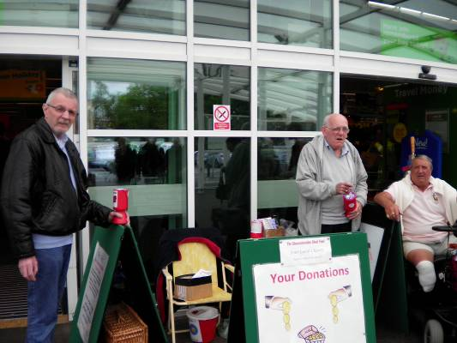
Doreen Roberts Award
The Trustee were pleased to award this year’s certificate to Patrick O’Mahoney (left of picture) seen here collecting at ASDA with John Rush and Dennis Hayward. Chest Fund supporters. Unfortunately Pat was unable to attend our social event because he was in hospital.
Dr. Andrew White, on behalf of all the trustees, presented the certificate which was collected by John Rush on Patrick’s behalf. He mentioned that Pat was a regular supporter of the Chest Fund, a regular worker at store and car park collections and an ‘all round asset to our charity’

One More Appeal

Over the years I have tried desperately hard to update our supporters’ database. Occasionally some kind person will take the time to email or write to me to let me know that one of our supporters has passed away but I’m convinced that our records still need of updating Please, please, please, if you are not the person to whom this newsletter is addressed or if you are no longer interested or able to help our charity just drop me a line, give me a ring or send me an email. You will then cease receiving letters from me that you may not want and you’ll save the Chest Fund some very expensive postage.
Thank you for your help on this one.

A Very Special Person

All our supporters and volunteers are special to us but we now need the help of someone living in or around Cheltenham to further our activities in that area. We need someone who would organise and arrange staff for fundraising events such as store collections, coffee mornings, sponsored sporting events and any other means they can think of to develop the Gloucestershire Chest Fund in Cheltenham. I will provide all administrative support including posters, tickets and anything else needed. Please contact me via letter, phone or email to get any additional information you may need to help you decide to undertake this most important role.

2012

We havealready organised a fair number of activities for 2012. There will be more but we must first ask for your support for the events listed on the next page. We need you to help with fundraising activities and to give your support for social activities such as jazz evenings and the Christmas social. Please have a look at the list on the next page and let us know if you are able to help in any way..

A Special ‘Thank You’
We cannot succeed without your support and we cannot thank you enough for it.

If you’re receiving this newsletter it means that you have helped us at some time in 2011. Thank you for your support and may we please rely on it again in 2012?
Office
Your sincerely Suite ‘E’, The City Business Centre, Llanthony Road
Ron Hannam Gloucester GL2 5JH
Fundraiser 01452 300212 gloschestfund@btconnect.com.

Open Annual General Meeting and Presentation of Portable Ultrasound Scanner
The Trustees are pleased to invite you to attend our Annual General Meeting at MidGlos Indoor Bowling Club, Green Street, Brockworth,Gloucester GL3 4LS on Wednesday 6th. June 2012 at 6.00pm.
R.S.V.P. by 29th. May 2012 to assist catering arrangements

Fundraising Events April - December 2012

Date | Event |  | Times |  | Availability |  | Telephone
April 14 | Store Collection  Morrisons  Up Hatherley |  | 10.00 am till 4.00pm |  | 10.00 – 12.00  12.00 – 2.00  2.00 – 4.00
 | ASDA, Gloucester |  |  |  | (Please tick as appropriate)
April 14 | Store Collection  ASDA Up Hatherley |  | 10.00 am till 4.00pm |  | 10.00 – 12.00  12.00 – 2.00  2.00 – 4.00
May 5th | Store Collection  ASDA, Gloucester |  | 10.00am till 4.00pm |  | 10 – 12.00  12.00 – 2.00  2.00 – 4.00
June 23rd. | Store Collection ASDA, Gloucester |  | 10.00am till 4.00pm |  | 10 – 12.00  12.00 – 2.00  2.00 – 4.00
July 7th. | Car Park staffing, Rikenel, Gloucester |  | 8.00am till 3.00pm |  | 8.00 – 10.00  10.00 – 2.00  2.00 – 3.00
July 23rd.  24th.  25th | 3 day Store collection  Sainsbury’s |  | 10.00 am til 4.00pm |  | Help desperately needed, please book as much as you can
 | Tewkesbury Road | Each day
 | Cheltenham
28th | Store Collection  ASDA, Gloucester | 10.00am till 4.00pm |  | 10.00 – 12.00  12.00 – 2.00  2.00 – 4.00
August 25th. | Sponsored Skittles match v’s Victory Hotel, Tredworth Road, Gloucester | 7.00pm start |  | No help needed – just come along and enjoy
September 29th | Store Collection Sainsbury’s, Stroud | 10.00am till 4.00pm |  | 10.00 – 12.00  12.00 – 2.00  2.00 – 4.00
December 7th. | Christmas Social and Draw | 7.30 – 10.30 |  | We’ll do the work – just come and enjoy

