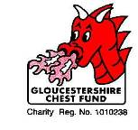

Newsletter

SUMMER 2006
Your Chest Fund Needs
You!

Dear Friends,

We have now reached halfway in 2006 and it has, so far, been a year of ‘Good News’ and ‘Bad News’.

The sad, sad news is that we have lost one of our most loyal, long standing supporters. Iris Lewis of Harefield Farm, near Stroud was an accomplished musician, a witty and entertaining speaker and a lovely lady. Her talk entitled ‘Khaki Bloomers’ was delivered to many organisations over the last 12 years and she always declined a Speakers Fee but invited donations to the Gloucestershire Chest Fund. 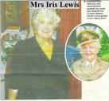
The photo shows Iris as she was at the Cheese and Wine party when she was presented with the ‘Doreen Roberts Award’ for outstanding service to the Gloucestershire Chest Fund. Inset as she was when she served in the ATS.
Our sincere, heartfelt condolences go to Iris’s husband Roy.

Time To Think and act.

Over the last few years our supporters have been steadily dwindling due to ill health, age and death. We cannot prevent any of these causes but we can offset them. You have been magnificent because, in spite of this reduction in active support, you have produced more money to be spent supporting our doctors and nurses. I would now ask you to try to recruit some active friends, relatives and neighbours to keep the Fund alive. Any age from 18 upwards. If they have ideas we would like them to join our Events Committee. This Committee meets six times per year, about 3 hours per meeting, to plan activities and organise the staffing. Other volunteers are needed to staff events but nobody is asked to devote more than 20 hours per year. Who do you know who fits the need?

Suttons, the Seed merchants, are offering to donate 20% of any order purchased from their ‘Fundraiser’ catalogue. The catalogue is a 16 page Bulb catalogue that should be of interest to all the gardeners amongst you. The catalogue is free; the goods are guaranteed and will be delivered direct to your home.
Would you like a catalogue? If so, write me at the office, phone me at the office or at home, e-mail me at gloschestfund@tiscali.co.uk. I will order the catalogues and forward them to you. Whatever you spend we will get 20%.

Please don’t forget:

Saturday 15 July 2006. We need staff to run the Rikenel car park in Gloucester. Paul Beard and I will do the early stint. We need help from 10.00am onwards. Can you spare 2 hours please?

Use the enclosed list or phone me at the office 01452 300212, at home on 01452 536202.
What a result!

Dr Bernard Lucas kindly offered to run the London Marathon for the Gloucestershire Chest Fund.

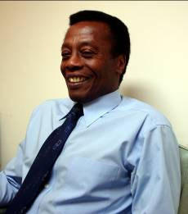
Distance: 26 miles 385 yards.

Time: 3 hours 33 minutes 7 seconds.

Sponsorship up to 12 June 2006. £730.

Bernard was 62nd. in his age group in spite of losing a big toe nail half way round.

‘Thank you Bernard – your support is invaluable – please get your foot well because we’d love you to do it again for us next year.’

Charity begins at home
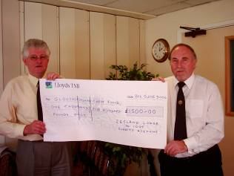
Zetland Lodge of Freemasons showed just what they
understand by this ‘well known phrase or saying by
donating a cheque for £1,500 to the Gloucestershire
Chest Fund. Dr Peter Roscoe received the cheque from
Worshipful Brother Pat Sully, Immediate Past Master
of Zetland Lodge who had nominated the Chest Fund
as his personal charity for the year. Dr. Roscoe thanked
the Brethren of Zetland Lodge for their superb support
and assured W.Bro Sully that the money would be spent
to help local hospitals treat chest diseases. The Fund is
committed to funding equipment that will cost around
£30, 000 and donations such as this make invaluable
contributions.

How’s your Grandchildren?

Many schools encourage their pupils to organise charity events or sponsored sporting activities. This helps the young people to develop management and organisational skills and at the same time to gain a sense of community spirit. Usually, I am told, the ideas of which charity to support by these activities comes from the pupils. How about your grandchildren? Does their school have such activities? If so could you ask them to consider the Gloucestershire Chest Fund? We are local and all our efforts are for local hospitals and medical centres. We do not have large wage bills or spend fortunes on advertising.
We simply find out what is needed by asking the Thoracic Consultants and we raise the money to supply it.

Thank you all for your continued support.
Ron Hannam

