

The Wheeze Newsletter Summer 2014

The Trustees are delighted to report that following presentation of a very detailed submission and business case, the Gloucestershire Hospitals’ NHS Foundation Trust agreed the procurement, by the Chest Fund, of Pleura Video Scope Equipment at a cost of £33,000.

The purchase of this equipment, described as an exciting development in respiratory medicine, was made possible by the outstanding generosity of the late Mrs Barbara Elston, who was a patient at Gloucestershire Royal Hospital under the care of
Dr A J White. The presentation was a particularly poignant occasion as Chris Elston, Barbara’s son, travelled from Solihull to present the equipment to the Chest Consultants.

Dr Henry Steer gave a detailed report on the operation of the equipment and he answered a number of pertinent questions. Dr A Raghuram said that he was delighted that a large number of the county’s chest sufferers would benefit from the use of this state of the art equipment.

The presentation held on Wednesday 30th. April 2014 was attended by many supporters, volunteers and, of course, our Trustees. Mr Bernard Cooper, Chairman, acknowledged the outstanding generosity of Barbara and he also gave a detailed report on the achievements and progress of the Fund over the last 12 months.
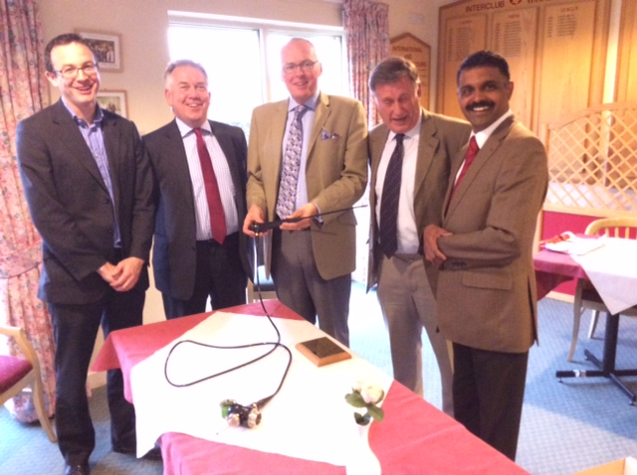
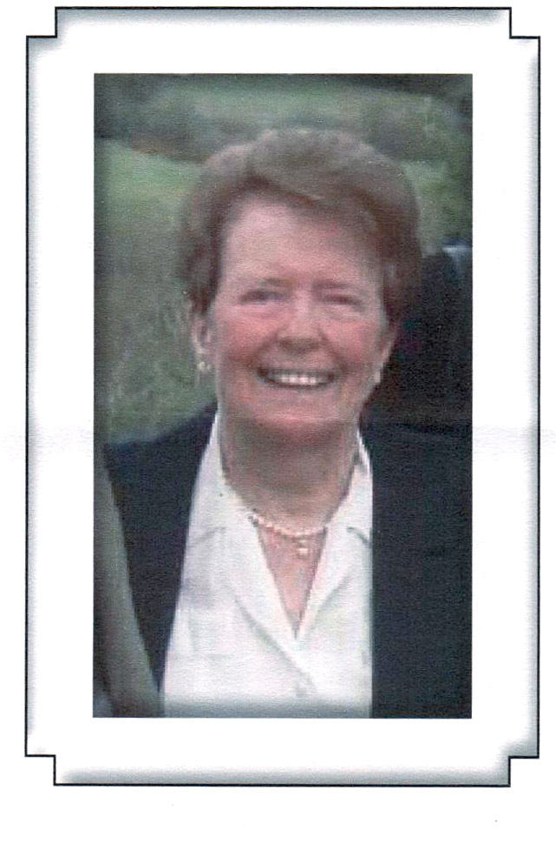

Presentation Party
Left to right: Dr Henry Steer, Dr Geoff Meecham-Jones
Mr Christopher Elston,Mr Bernard Cooper (Chairman)
Dr Ananthakrishnan Raghuram.

The late Mrs Barbara Elston whose generosity will benefit many present and future chest patients

The Chest Fund continues to supply small items of medical equipment as well as funding training courses for respiratory nursing staff. The Trustees are also considering the procurement of nitric oxide analysers at a cost of £5,000

We achieve these targets by the loyal support of organisations such as the Gilbert Lane Charitable Trust and it was delightful to see Mrs Janet groves at the presentation. We must also acknowledge the outstanding support we receive from the Gloucester Severnside Rotary Club, The Brockworth R.A.O.B, Rotary Kingsholm and many other Service Clubs.

Our own fundraising activities continue to prosper particularly store collections organised and operated by Mr Pat Dowling and his dedicated team of supporters.In the past four months we have conducted eight store collections and raised in excess of £1,300.We have another eight booked for the latter half of the year and your help would be most welcome. The public are, at last, getting to know us and collecting has become so much more enjoyable because of it. Will you try it by making yourself available for a couple of hours? Please see the list at the back of the newsletter and let me know.

Our annual skittles match will be held at the Ukrainian Club in Midland Road, Gloucester when the Chest Fund All Stars will face a new challenge from the home team. The event will take place on Friday 29th. August at 7.00pm. The facilities at the Ukrainian Club are excellent, good food, drink and a brilliant atmosphere. Why not come along and enjoy it? The Fund will benefit by six or seven hundred pounds and you’ll have a great night.

The Annual Swimathon , held at Virgin Active, Brockworth will be held later in the year due to the refurbishment of the indoor pool: details in the next newsletter.

Christmas comes but once a year!
I’m delighted to report that each year our Social seems. more successful. Much of the growing popularity can be attributed to Linda Purchase and her talented family and friends who provide the varied programme of musical entertainment. Special thanks are also extended to Bernard Cooper and Terry Adams who organise the splendid refreshments.
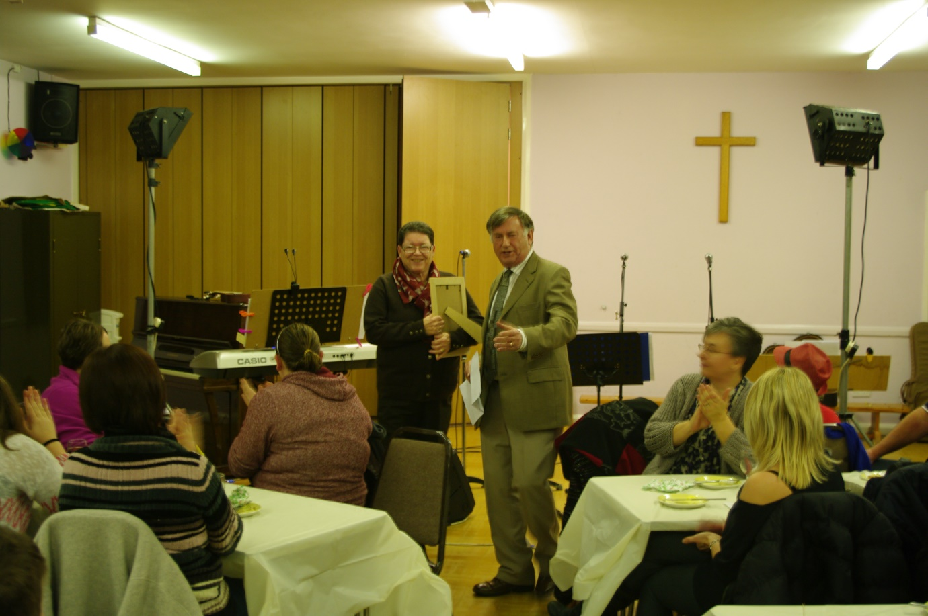

Elaine Padmore ,this year’s winner of the Doreen Roberts Award for outstanding Chest fund support receives her certificate from Chairman Bernard Cooper

The date for your diaries is Friday 28th. November 2014. The venue is the St Georges Church Hall, Court Road, Brockworth, Gloucester, the time 7.00pm till 10.30pm, tickets £8.00 each. What can you lose? Come along and meet the rest of the Chest Fund supporters. Tickets will be available in our next newsletter.

Michelle Jefferies ,part of the family management team at the Kings Head, Birdwood, Glos. Is going to celebrate her ‘Life begins at’ birthday by challenging 54 kilometres of Brecon Beacons in the Brecon’s Trek. Much of the course will be over the S.A.S. training ground so it will be very hard work. Michelle is doing this for the Gloucestershire Chest Fund. We thank her and wish her well.

Our intrepid Chairman, Bernard Cooper and Rhiannon Parry are again taking on the Cheltenham Circular Challenge, 26 miles of truly tough country around Cheltenham. Based on previous years I would expect the money raised by Rhiannon and Bernard to approach if not exceed £400 in total.
How’s that for being an active Chairman!

If you would like to sponsor Michelle, Rhiannon or Bernard (or all three!) please send your donations to the office .

If you prefer to donate on line with credit or debit card go to: mydonate.bt.com/thegloucestershirechestfund and give whatever you wish – we will greatly appreciate it.

Pat and Carol Dowling with Gill Ford attended a Tesco Cheese and Wine evening designed to find out what charities thought of the support they received from Tesco, Brockworth and what they generally thought of the store. Pat came away with four extra collecting dates leading up to Christmas. A big ‘Thank you’ to Community Champion Laura Pittaway and especially to Tesco, Brockworth.

We are making good progress in our fundraising by sponsored events. If people can do what they enjoy doing and raise money for their favourite charity it can only be good.

Do you have a relative of friend who would run for us, walk for us, swim for us, cycle for us?
They simply find an event they would like to enter, we’ll pay the entrance fee and they nominate the Gloucestershire Chest Fund as the recipient charity. We’ll provide sponsor forms, tee shirts, posters to display their activity and help in any way we can. You may, perhaps, prefer to organise an event for us, run a raffle, hold a coffee morning or anything you can do to help. We will appreciate it.

The Gloucestershire Chest Fund has come a very long way since it was founded in 1991. I joined in 2002 and I can see the increase in activity and public awareness to a point where we honestly have a charity to be proud of.

Thank you for all your support.

Ron Hannam

Still to come in 2014

The following list of ‘fundraising events are still to come and provide you all with an opportunity to help our charity and meet other supporters. Please let me know if you’d like to help.

June
Sunday 7th. Michelle Jefferies tackles the Brecon Beacons Trek. Please send your
cheque or go to mydonate.bt.com/the Gloucestershire chest fund to donate
on line

Saturday 15th. ASDA store collection. Help welcome 10.am till 4.00pm
Sunday 22nd. Rhiannon and Bernard take on the Cheltenham Circular Challenge.
Please sponsor by cheque or on line.
Friday 27th. ASDA store collection 10.00am – 4.00pm Any volunteers??
July
Saturday 5th. Rikenel Car Park 8.00am – 3.00pm. Park all day for only £2.00

August
Saturday 16th. ASDA store collection – volunteers welcome.

September
Friday/Saturday 19th and 20th. Two day collection at Tesco, Brockworth, help
needed.
Saturday 27th. ASDA store collection 10.00am – 4.00pm

October

Saturday 25th. ASDA collection 10.00am – 4.00pm

November

7th. & 8th. Tesco Brockworth, two day store collection – Help needed please.
22nd. Morrison’s Abbeydale, store collection – Help needed please
28th. Christmas Social at St Georges Hall – All we need is you!!!
29th. ASDA store collection 10.00am – 4.00pm

December
18th & 19th. Tesco, Brockworth store collection,– Help needed please
20th. ASDA store collection 10.00am – 4.00pm

