WHEEZE
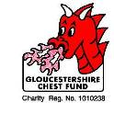

The Gloucestershire Chest Fund Ltd. Suite ‘E’, City Business Centre, Llanthony Road, Gloucester GL2 5JH. Tel: 01452 300212

ISSUE No.6

The Voice of the Gloucestershire Chest Fund

We are:
A non-profit making registered charity, managed by Trustees, supported by volunteers and working to help develop centres of excellence in the county of Gloucestershire for the detection, diagnosis and treatment of chest diseases.

Welcome
To issue No.6 of ‘The Wheeze’ the magazine of the Gloucestershire Chest Fund.
We aim to inform. We try to entertain. We hope to interest.

The last two years have seen the supporters of the Gloucestershire Chest Fund raise and spend more money than in any similar period of our history.

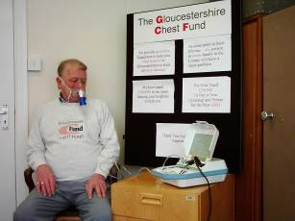

The Trustees

Mr T S Adams F.F.A.

Mr P B Evans J.P

Dr. R W lamb
M.B,B.S,D.A,D.obs,R.C.O.G.

Mr N C Mitchell
F.C.M.I,FinstR,M.R.A.C.

Dr.I L Mortimore
BSc,PhD,M.R.C.P.

Dr. A R L Penketh
BSc,M.D,F.R.C.P.

Dr. J G Prior
M.D, F.R.C.P

Councillor H B Roberts
F.F.B, F.S.A.E,F.I.A.M

Dr P Roscoe
BSc(Hons),F.R.C.P(Edin)

Mr J R Sissons

Administrator and Fundraiser
Mr R S Hannam

Paul Beard, demonstrates the use of a nebulizer while raising funds to help buy more equipment for Gloucestershire’s hospitals.
Patients like Paul need this kind of equipment to survive.
Some of it is outside the budgetary capabilities of the NHS. That’s where we come in.

We Did What We Set Out To Do:
We provided £22,500 to buy equipment for Cheltenham General Hospital.(See P. 5)

We undertook to trial and evaluate a pulmonary rehabilitation service for our county. We did just that. Twelve months trial at Gloucestershire Royal Hospital followed by six months measurement and evaluation at St. Pauls Medical Centre in Cheltenham. The results were an overwhelming, outstanding success. The National Institute for Clinical Excellence (N.I.C.E.) raised the priority for the need to provide this service from ‘C’ to ‘A’. The conclusion was that it works and it is viable.

The cost to the Chest Fund was £28,000. We’ve done our job, we can do no more.
The future provision of this vital service now rests with the Primary Care Trusts who control the money. Respiratory medicine, although dealing with the third biggest ‘Killer’ in Gloucestershire, appears to come a very poor third in the disposition of funds.
We can only wait for the NHS to do their job.

Introducing Jeff Sissons 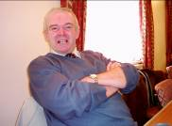
Our newest Trustee. Jeff is a retired businessman who brings skills, connections and enthusiasm that will be of great value to the Fund

Why have a Gloucestershire Chest Fund? We’ve got the National Health haven’t we?
In a perfect world we wouldn’t need any charity supporting the NHS in any field. Unfortunately we do not live in a perfect world. The NHS supplies only essential equipment and services. Hi-tech equipment is needed to ensure the patients get the best possible care. Often, by the time the administration accepts that equipment is essential it is almost redundant. We help the physicians by supplying up to date hi-tech equipment as soon as they establish the need. We need your help to help them!
Simon’s our champ!

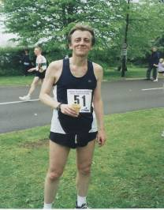
Simon Smith loves to run and he’s pretty good at it. He ran the Tewkesbury Half Marathon in 2002,2003 and 2004. All his times were commendable but in 2004 he achieved his best ever, 1 hour 25 minutes for 13 and a half miles.
His sponsorship in 2004 was also a record, £625 to help the Chest Fund. His total over the three years exceeded £1,200. We can’t thank him enough.

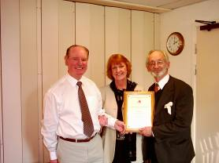

Mum Won Too
The Trustees of The Gloucestershire Chest Fund were delighted to show their appreciation for Jo Astbury’s outstanding contribution over many years by declaring her the 2004 winner of the Doreen Roberts Award. Jo, who is also Simon Smith’s mother, is seen receiving the certificate from Vice-Chairman Howard Roberts and Secretary/Treasurer Terry Adams

What else did we do?
In addition to the basic activities of our Administrator/Fundraiser, Ron Hannam, who is responsible for seeking the support of local councils and service organisations the Events Committee, ably supported by our small band of volunteers, has originated, organised and run a series of money raising events. These events, a few of which are shown here, have helped to contribute towards £30,000 raised in 2004.
Well done and thank you everyone.



Store Collection at Sainsbury’s, Stroud
Hilary Howe, Geoff Beetham, Paul Beard and Ron Hannam collected at the Sainsbury’s Supermarket in Stroud from 10.00am till 5.00pm and produced £172.00. Earlier in the year Mary and Colin Cavanagh, Geoff Beetham Paul and Ron collected for a similar time at Sainsbury’s, Barnwood for another £170.00
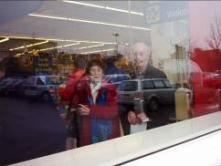

Toys ‘R’ Us
Vera Evans and Geoff Beetham are seen through the window of Toys ‘R’ Us, Gloucester. Ann Woolnaugh organised, staffed and controlled this event when the three of them worked from 11.00am till 4.00pm and raised a very creditable £117.00.

Rikenel
We also staffed the car park at Rikenel Health Centre in July when Trustee Howard Roberts and a wonderful group of Girl Guides supplemented our usual volunteers; this raised £225.00
This type of collection may not be particularly popular among the volunteers but in 2004 it raised just under £1,000. With more staff we could double that. WILL YOU HELP IN 2005?

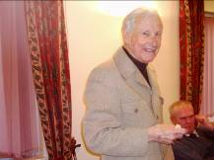

Mr Philip Evans J P, Vice Chairman

Phil Evans, writer by profession, has supported and served the Gloucestershire Chest Fund from the very early days.
In this article he quotes facts and figures recently published in a national daily newspaper

THE BOTTOM OF THE LEAGUE

Remember those days when we proudly boasted that the NHS was the envy of the world?

Well, a recently published league table of deaths due to respiratory diseases in Europe shows the UK firmly at the bottom. Twice as many deaths as Germany and France and well over three times that of Latvia and Hungary!

The British Thoracic Society, which represents respiratory specialists, is urging our Government to tackle the question of lung diseases – the third biggest killer in the U.K.

The writer of this report states that pouring extra money into the NHS in general is not the answer. More must be directed to respiratory needs. It says that there is and inadequate Government awareness of lung diseases. The number of Consultants in respiratory medicine is about one third per capita of most major European countries. Rehabilitation units are available to all patients in most European countries as routine.

Unfortunately, the British Government’s lack of awareness appears to have infected our Gloucestershire NHS Trusts. This Charity has been persistently pressing the local NHS to set up a Rehab. Unit for chest patients in our County – even to priming one up ourselves to prove its viability. But to no avail. THEY DON’T WANT TO KNOW!

Obviously this Charity is not able to continue to run and maintain a service which the NHS should be paying for.
RESEARCH SHOWS THAT PATIENTS UNDERGOING THE REHAB. SERVICE SPEND AN AVERAGE OF 11 DAYS LESS IN HOSPITAL COMPARED WITH THOSE NOT TAKING PART. THE QUALITY OF LIFE OF THOSE WHO PARTICIPATE IS SUBSTANTIALLY IMPROVED.

You don’t need to be a rocket scientist to work out the advantages of that, both financially and humanely but it tends to show why the U.K. is in the relegation zone in the European League of Chest Disease deaths.

In Gloucestershire we are blessed with dedicated Chest Consultants and Nursing Staff, they deserve all the back-up they can get.

So, if ever our local NHS decide to catch up with our European partners and most of the better British Hospitals, and set up a Rehab. Unit, then this Fund will offer to supply transport to and from that unit for patients without their own facilities.

SO COME ON NHS TRUSTS – YOUR PATIENTS ARE LOSING THEIR PATIENCE
We are:
A non-profit making registered charity, managed by Trustees and working to help develop centres of excellence in the county of Gloucestershire for the detection, diagnosis and treatment of chest diseases.
Fact:
One person in every family will suffer from a chest complaint at some time in their life. The NHS is able to fund only the essentials. The Gloucestershire Chest Fund
works to provide the extras

Reflections on our Founder
By Councillor Howard Roberts

At this time of the year my thoughts inevitably turn to the Trust and its work, as it is five years since its founder, my late wife Doreen, passed away. Happily the Trust continues to thrive but our help is more urgently needed than ever before. Sadly, some of the caring for which the Trust was established, is being ignored by the NHS. I refer, in particular, to the Pulmonary Rehabilitation Service that has helped so many chest patients and that should be reinstated if only to keep hospital beds free
and save money.

A gift of £20,000 from one of our staunch supporters enabled the service to be set up and subsequent funding was provided by the Gloucestershire Chest Fund to facilitate full evaluation and provide the appropriate submission to the relevant Primary Care Trust. However they, in their wisdom, did not consider it an essential service despite the decision of the National Institute for Clinical Excellence (N.I.C.E) to award it a category ‘A’ priority.

I am sure Doreen’s “Impossible Dream” would like to see the service re-established for the benefit of many Gloucestershire patients with C.O.P.D. We are still actively raising funds for Pulmonary Rehabilitation and we will readily support it’s introduction in other parts of the county or complement the service in some way.

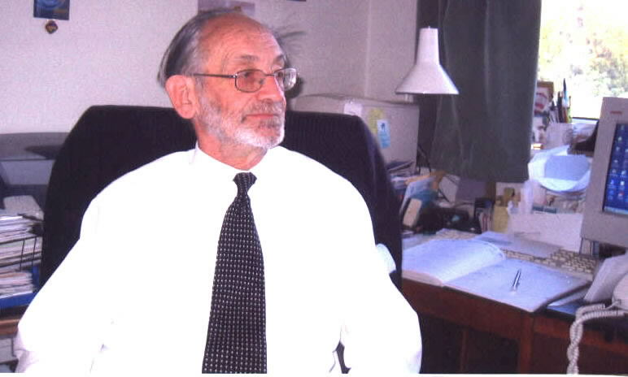

However, not everything is downbeat as we have recently purchased Cardio-pulmonary Exercise Testing Equipment for Cheltenham General Hospital at a cost of £22,000.
Dr Ian Mortomore, Respiratory Medicine Consultant, is delighted with the equipment and it is most encouraging to see happy staff and patients using state of the art
equipment to obtain information quickly and help their
condition

May I, in conclusion, thank all our volunteers and helpers for their dedicated support? To those who read this article may I say “ WE DO NEED YOUR HELP, HOWEVER SMALL” to make a courageous lady’s impossible dream come true.
~~~~~~~~~~~~~~~~~~~~~~~~~~~~

WILL YOU HELP?

help their
Councillor Howard B Roberts FIAM Vice-Chairman

Make a Donation? Help with Fundraising Events? Consider the Chest Fund in your Will?

Hold a coffee morning and raffle? Organise a sporting Event (sponsored run, swim crib)?

Place a Collecting Box in your local Store/Pub/Club and service it monthly?

Where Did All The Money Go?
Since our last publication we have invested £28,000 in our campaign to secure effective pulmonary rehabilitation facilities for the people of Gloucestershire. We have not won yet but we will! Keep trying
This picture, originally published in ‘Acute Angle’ shows Respiratory Specialist Nurse, Louise Scott-Hawkins supervising a patient on some of the equipment used to help acute chest sufferers to come to terms with their condition. The course, held at Gloucestershire Royal Hospital, showed them that they could do a great deal more than they thought they could and gave them the confidence to do it.
The Gloucestershire Chest Fund proved the course works and is viable because it keeps patients out of hospital.
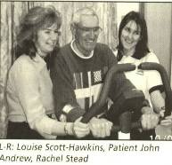

This photograph and comment by Norma Greener was originally published in the GloucestershireEcho on 18/2/04. Her comment, echoed by most patients on the course, justifies the money we spent. The service ran for 1 year and cost £20,000.
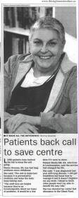
The photograph on the right, published in the Echo on 28/6/04 shows Louise Scott-Hawkins and Rachel Stead helping patient Sheila Hill during the evaluation tests of the service that took place in St Paul’s Medical Centre in Cheltenham. Results were carefully monitored and submitted to P.C.T for future funding. The service ran for six months and cost £8,000
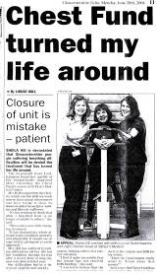

Cardio-pulmonary Exercise Testing Equipment, £22,000
Dr Ian Mortimore says:
Thanks to the Gloucestershire Chest Fund and supporters from around the county we now have “state of the art” cardio-pulmonary exercise testing equipment. This is located at Cheltenham General Hospital but is used for patients countywide. So why do we need this piece of kit?
There are three main causes of shortness of breath, namely anaemia, cardiac disease and respiratory disease. Patients presenting respiratory symptoms usually complain of a cough, shortness of breath or wheeze. Many patients have a combination of these symptoms that can be caused by a long list of conditions. In most patients elucidating the cause of the symptoms is fairly straightforward and requires only simple investigation, for example, peak flow recordings used to diagnose asthma. For other patients we have more sophisticated pieces of equipment and scanners that can look at the lungs and the way they work in more detail. However, all these tests are performed at rest but most patients complain of shortness of breath when they are exercising, even if only walking 50 yards to the local shop. Occasionally, even after performing our battery of tests we are still not sure why some patients are short of breath. This is where exercise testing is important. This new equipment will allow us to monitor
ventilation, heart rate, pattern of breathing and oxygen and carbon dioxide output whilst patients are actually exercising. In most instances this will help us decide why patients are short of breath and, therefore, how best to treat them
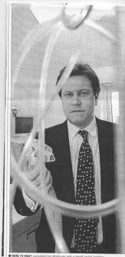

Where to now?
Inpatient facilities have been transferred from Standish Hospital to the Gloucestershire Royal. They will be housed in wards 8a and 8b. These wards will provide specialist chest services as in E1 and E2 at Standish. There will also be a high dependency unit on one of the wards where more seriously ill patients can be closely monitored. Many of the staff from Standish have also transferred.
This means a need to replace ‘outdated’ equipment. This means money. Your donation, your raffle, your coffee morning. We have taken a low profile in the first month of this year because the dreadful Tsunami disaster has needed your attention and your sympathetic support but now we must look to our own needs. We are currently collecting for a Tosca Monitor, a machine that will remove the necessity, in many cases, to stick needles into veins to extract blood for analysis. The monitor will provide much of the required information via a sensor. This will be a great help to the medical staff and a great comfort to patients whose veins have collapsed or are difficult and painful to find.
The cost will be £9,000 per machine. Will you help please? Contact Ron Hannam on 01452 300212 or send your donation to the Gloucestershire Chest Fund, Suite ‘E’, City Business Centre, Llanthony Road, Gloucester GL2 5JH.
That’s All Folks – I hope you enjoyed Wheeze No.6, please take care and stay healthy!
In the meanwhile why not try the Wheeze Word Search – no prizes, just a bit of fun!
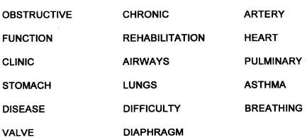
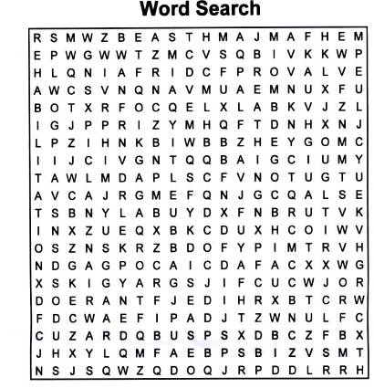

Trustee Profile
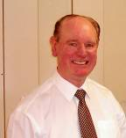

Mr. T S Adams F.F.A.

Terry Adams has been a great friend to the Gloucestershire Chest Fund from 1991, shortly after the Fund was created. He joined as Treasurer and was invited onto the Board of Trustees in that capacity.

Over the years he has assumed more and more duties. With the sad death of our Founder, Doreen Roberts, Terry also assumed the role of Secretary to ensure the continuation of the Fund in the absence of any other suitable volunteer.

His support of our charity has been quite magnificent
Thank You Terry!

